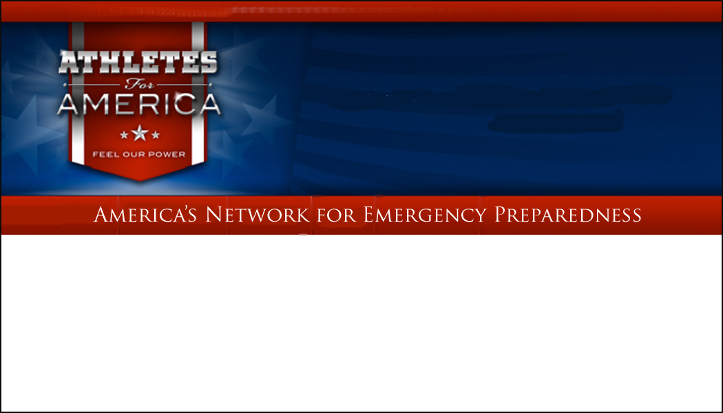

(**Insert Date**)

American Heart Association Instructor,

You are a leader with AHA and in your community. You understand and live the concept of being there for others, of being prepared to respond and act under any circumstance – planned or unplanned. As you are aware of, emergencies and disasters occur around us every day. But did you know that every three days, an athlete suffers from a cardiac emergency on the field of play? This is why we need your help!

**ATHLETES FOR AMERICA** (**AFA**) is a National organization founded after the September 11th attacks. Its Founder, Billy McGehee, envisioned the idea of creating a safer Nation utilizing the strength of the Athlete and the power of sports. Its mission is to train every American Athlete as a first responder, able to save lives in times of emergencies. On (**insert day of week**), (**insert month/date**), **AFA**, in partnership with you, will train athletes in CPR and the use of an Automated External Defibrillator (AED). **AFA** hopes that you, along with other Instructors will come together to train our young athletes as first responders.

We promise this event will be exciting! This day ***will*** change your life forever because **YOU** will become part of the largest, civilian, emergency preparedness network in America’s history. Every athlete you train will help us create a safer America.

Please contact (**insert contact name**) at (**insert contact’s phone and email**) by (**insert deadline date)** to register.

Learn more about **AFA** by visiting the website: [www.athletesforamerica.org](http://www.athletesforamerica.org)

***SAVE A LIFE… CHANGE THE WORLD!***

Remember…… September 11, 2001

**FEEL OUR POWER!**